\*Project

\*Sells Report\*

Submitted By

Name: Abu Khalid Siddique

ID: 22203047

Section: F

Submitted To

Suhala Lamia Mam

Outlines:

1. Code
2. Output
3. Flowchart
4. Algorithm
5. Code & Output Photo

\*CODE\*

#include <stdio.h>

int main()

{

int w=100,x=100,y=100,z=100,p=120000,q=75000,r=185000,s=135000,n,i,sumphn=0,sumpod=0,sumbook=0,sumimac=0,profit=0,sell,total;

printf("WELCOME TO\nAPPLE Gadget Store\nBranch: Sector 10, Uttara, Dhaka 1203\n");

printf("Available Products In This Branch\n1. Iphone 14: %d pieces & Per Price: %d Taka Only\n2. Ipod 5: %d pieces & Per Price: %d Taka Only\n3. Macbook: %d pieces & Per Price: %d Taka Only\n4. Imac: %d pieces & Per Price: %d Taka Only\n",w,p,x,q,y,r,z,s);

printf("Check The Sells Report From Day 1 to Day ");

scanf("%d",&n);

for(i=1;i<=n;i++)

{

printf("Enter The Number Of Products Sold in day %d:\n",i);

printf("Enter Day %d , Iphone 14 Sold: ",i);

scanf("%d",&sell);

sumphn+=sell;

printf("Enter Day %d , Ipod 5 Sold: ",i);

scanf("%d",&sell);

sumpod+=sell;

printf("Enter Day %d , Macbook Sold: ",i);

scanf("%d",&sell);

sumbook+=sell;

printf("Enter Day %d , Imac Sold: ",i);

scanf("%d",&sell);

sumimac+=sell;

}

printf("Till Day %d The Total Number Of Products Sold:\n1. Iphone 14: %d\n2. Ipod 5: %d\n3. Macbook: %d\n4. Imac: %d\n",n,sumphn,sumpod,sumbook,sumimac);

printf("The Remaining Products\n1. Iphone 14: %d\n2. Ipod 5: %d\n3. Macbook: %d\n4. Imac: %d\n",w-sumphn,x-sumpod,y-sumbook,z-sumimac);

total=sumphn\*p+sumpod\*q+sumbook\*r+sumimac\*s;

printf("\nTotal: %d Taka Only\n",total);

profit= total\*0.05;

printf("profit: %d Taka Only\n",profit);

printf("THANK YOU");

return 0;

}

\*OUTPUT\*

WELCOME TO

APPLE Gadget Store

Branch: Sector 10, Uttara, Dhaka 1203

Available Products In This Branch

1. Iphone 14: 100 pieces & Per Price: 120000 Taka Only

2. Ipod 5: 100 pieces & Per Price: 75000 Taka Only

3. Macbook: 100 pieces & Per Price: 185000 Taka Only

4. Imac: 100 pieces & Per Price: 135000 Taka Only

Check The Sells Report From Day 1 to Day 3

Enter The Number Of Products Sold in day 1:

Enter Day 1 , Iphone 14 Sold: 4

Enter Day 1 , Ipod 5 Sold: 6

Enter Day 1 , Macbook Sold: 2

Enter Day 1 , Imac Sold: 1

Enter The Number Of Products Sold in day 2:

Enter Day 2 , Iphone 14 Sold: 9

Enter Day 2 , Ipod 5 Sold: 3

Enter Day 2 , Macbook Sold: 7

Enter Day 2 , Imac Sold: 5

Enter The Number Of Products Sold in day 3:

Enter Day 3 , Iphone 14 Sold: 5

Enter Day 3 , Ipod 5 Sold: 8

Enter Day 3 , Macbook Sold: 4

Enter Day 3 , Imac Sold: 2

Till Day 3 The Total Number Of Products Sold:

1. Iphone 14: 18

2. Ipod 5: 17

3. Macbook: 13

4. Imac: 8

The Remaining Products

1. Iphone 14: 82

2. Ipod 5: 83

3. Macbook: 87

4. Imac: 92

Total: 6920000 Taka Only

profit: 346000 Taka Only

THANK YOU

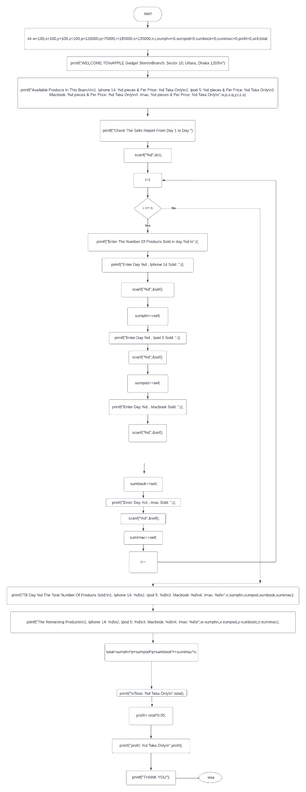

\*FLOWCHART\*

\*ALGORITHM\*

Step 1: Start

Step 2: declare variables int w=100,x=100,y=100,z=100,p=120000, q=75000,r=185000, s=135000, n,

i, sumphn=0, sumpod=0,sumbook=0,sumimac=0,profit=0,sell,total;

Step 3: display WELCOME TO\nAPPLE Gadget Store\nBranch: Sector 10, Uttara, Dhaka 1203

Step 4: display Available Products In This Branch

1. Iphone 14: 100 pieces & Per Price: 120000 Taka Only

2. Ipod 5: 100 pieces & Per Price: 75000 Taka Only

3. Macbook: 100 pieces & Per Price: 185000 Taka Only

4. Imac: 100 pieces & Per Price: 135000 Taka Only

Step 5: display Check The Sells Report From Day 1 to Day

Step 6: if condition (i=1; i<=n; i++) true go to step 7 else go to step 17

Step 7: display Enter The Number Of Products Sold in day

Step 8: read sell of iphone 14

Step 9: sumphn=sumphn+sell

Step 10: read sell of ipod 5

Step 11: sumpod=sumpod+sell

Step 12: read sell of macbook

Step 13: sumbook=sumbook+sell

Step 14: read sell of imac

Step 15: sumimac=sumimac+sell

Step 16: i incremented then go to step 6

Step 17: display sum total number of product sold

Step 18: display sum total number of product remaining

Step 19: total=sumphn\*p+sumpod\*q+sumbook\*r+sumimac\*s

Step 20: display total

Step 21: profit= total\*0.05

Step 22: display profit

Step 23: display THANK YOU

Step 24: stop

\*CODE &OUTPUT\*

\*PHOTO\*

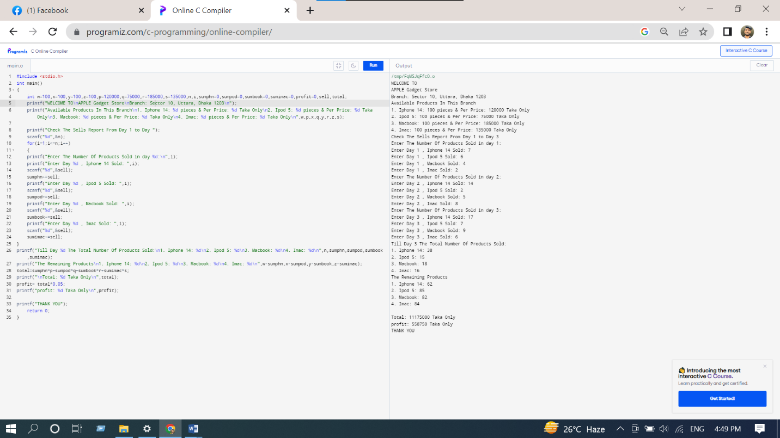

\*Thank You\*